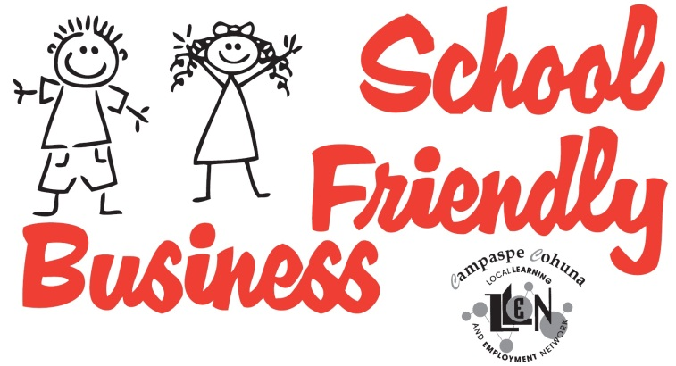
Becoming a School Friendly Business
Tick at least 6 of the following boxes:
Our Business is aware of important school dates
We will consider flexi time for parent/guardian employees to attend significant school events
We will welcome authorised school and parenting promotional literature in our staff room
We are prepared to host workplace learning (work experience, work placements and/or school based apprentices) and tours of our worksite
We would consider mentoring students
Our business engages with the Beacon Foundation
We would like to be invited to important school events
We are keen to help train potential employees
We want to be part of the ‘village that raises a child’
Other involvement (please describe)

Yes, I / We are interested in becoming a School Friendly Business

Name of Business or Organisation:
Manager / Executive Officer / Director:

Contact Details

Telephone:
Mobile:
Email:
Web Address:

Fill in and mail back to CCLLEN, PO Box 273, Echuca VIC 3564
OR- Call 03 5482 6055 or email admin@ccllen.com.au for a form to be sent out or delivered to you

